Combi-Therm 3-layer Thermal carrierbag

Specifications:

Item No…………. | : | Medico 5
Print……………... | : | Standard is without any print
Size……………... | : | W 400mm x H 410/50mm + 50mm flap
Outerfoil………… | : | 55 micron silver pe
Insulation……….. | : | 70 gr/m² polyester fibers
Innerfoil…………. | : | 55 micron silver pe
Handle/closing…. | : | Tape closing/sealing –system
Carton…………… | : | 75 pcs. - size 59x39x31cm
Pallet……………. | : | 24 crts. - EUR 80x120x207cm

The 3-layer quality thermal bags from Combi-Therm/Cot products A/S are made of strong high-tech and lightweighted thermal material, produced in Denmark and exported all over the world. During the years the 3-layer thermal bags continuosly have been improved, offering the best possible thermal bag solution. A quality thermal bag consist of min. 3 layers of which one layer is made of insulation material (PE foam or polyester fibers).The 3-layer thermal carrier bags from Combi-Therm/Cot products A/S are produced of PE with respect for the environment, are food safe (FDA and BGA approved) and can be recycled.

Photos are showing the “Medico 5” model (front/back)

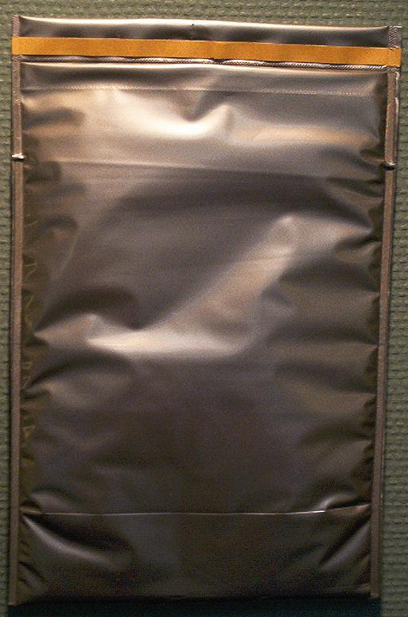

Salten Skovvej 2, DK-8653 Them, Denmark
Phone: +45 86 84 73 66
Fax: +45 86 84 80 77
E-mail: ct@ct-mail.dk
Internet: www.combi-therm.dk

